**How to download**

**Click on 3 dots and select download option**

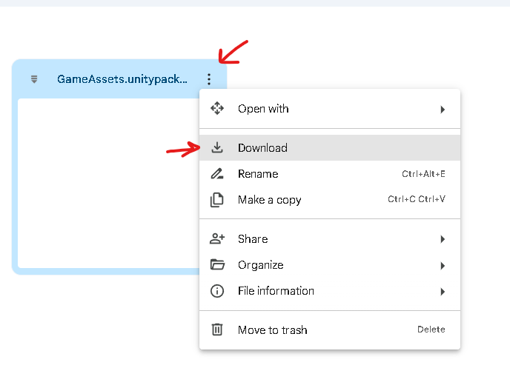

**Your package file should be downloaded with this unity logo**

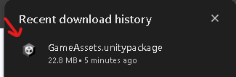

**What not to do**

**Do not open the file and download. This will download all the files as separate files.**

